The Melbourne Colonial Dancers
Dance – 3rd Thursday Every Month
7.30pm to 10.00pm
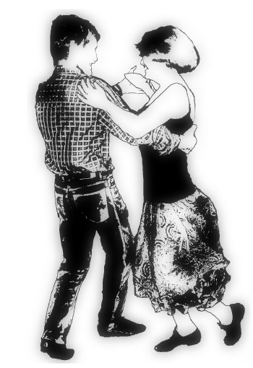
Followed by a light supper
Social Australian
Colonial/Bush dancing
for beginners and
experienced dancers
Contact
Coral
03 9885 6109 / 0468 739 761

THE MELBOURNE COLONIAL DANCERS ALSO MEET WEDNESDAY EVENINGS AT
COLLINGWOOD SENIOR CITIZEN’S HALL, EDDY CRT, ABBOTSFORD FROM 8PM

Ashburton Uniting Church Hall
Ashburn Grove, Ashburton
Entry $10, Members $8
Phone: Kate 0408 331 574
Email: secretary@melbournecolonialdancers.org.au
Website: www.melbournecolonialdancers.org.au
The Melbourne Colonial Dancers
Dance – 3rd Thursday Every Month
7.30pm to 10.00pm
Followed by a light supper
Social Australian
Colonial/Bush dancing
for beginners and
experienced dancers
Contact
Coral
03 9885 6109 / 0468 739 761

THE MELBOURNE COLONIAL DANCERS ALSO MEET WEDNESDAY EVENINGS AT
COLLINGWOOD SENIOR CITIZEN’S HALL, EDDY CRT, ABBOTSFORD FROM 8PM

Ashburton Uniting Church Hall
Ashburn Grove, Ashburton
Entry $10, Members $8
Phone: Kate 0408 331 574
Email: secretary@melbournecolonialdancers.org.au
Website: www.melbournecolonialdancers.org.au

