MCD’s Phyrne Fisher 1920’s Ball Dance Descriptions

Parma Waltz 32bar Waltz et al
Upper promenade hold
4 Bars Both commence on the left foot 2 steps forward and ½ turn
clockwise on the 2nd step and 3 quick steps backwards along
line of dance(LOD).
4 bars Starting with right foot repeat above against LOD back to
starting place.
4 bars Facing LOD starting left foot take 4 slow steps forward
8 bars 2 Lock steps to left (Lady in front) then 2 to the right
(Men in front) and repeat.
4 bars Walk 2 steps forward and turn to face partner balance away
and together into waltz hold.
8 Bars Waltz.

SYBIL'S ROUNDABOUT
Circle mixer for couples / 32-bar American reels
[Les Wooton: English Dance and Song Spring, 1972]
4 bars All: Advance to the centre 4 steps and retire
2 bars All: Advance in again
2 bars Ladies: Retire while… Gents: Turn round in centre to
face partner (4 steps)
4 bars Do si do right partner
4 bars Chassé 2 steps left + Chassé 2 steps right

4 bars Give LH to Partner & RH to Neighbour forming a wavy line
(Gents facing out) – Balance fwd & back +
Allemande LH 1/2 way (with Partner)
4 bars Give RH to next Neighbour forming a wavy line
(Gents facing in) – Balance fwd & back + Allemande RH ½ way
(with current Neighbour = next Partner)
4 bars Allemande LH with the next 1 full turn +
Go back to the new Partner
4 bars Swing
32 Repeat

Maxina
Couples both facing (L.O.D.) in high promenade hold position.
Rocking. Both rock forward onto left foot then back on right twice.
Starting on left foot take 3 steps and lift foot forward and 3 steps back.
2 slow steps forward stating with left. Then ½ turn clockwise on the right to face against LOD and run 3 quick steps backwards.
Starting right foot repeat the 2 slow ½ turn 3 quick back to place.
Starting left foot take 4 grape vine steps.
2 slow starting left ½ 3 quick then with right 2 slow ½ turn 3 quick.
Staring left take 2 slow steps forward then turn to face partner. Balance away and together take ballroom hold
Waltz.  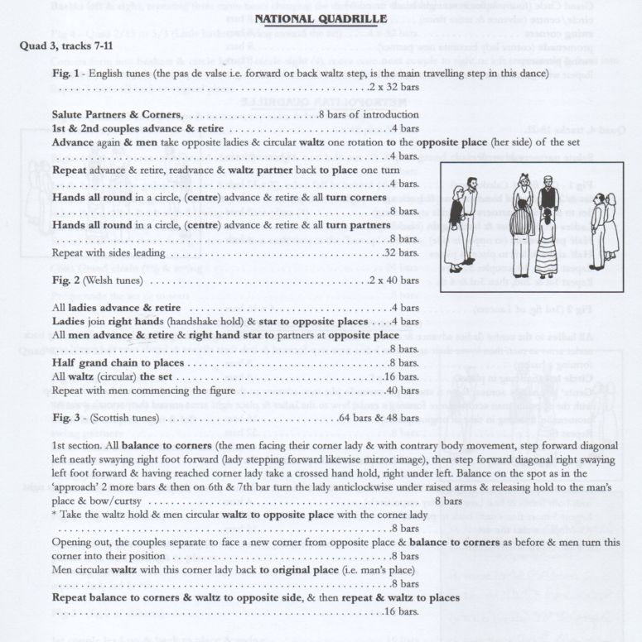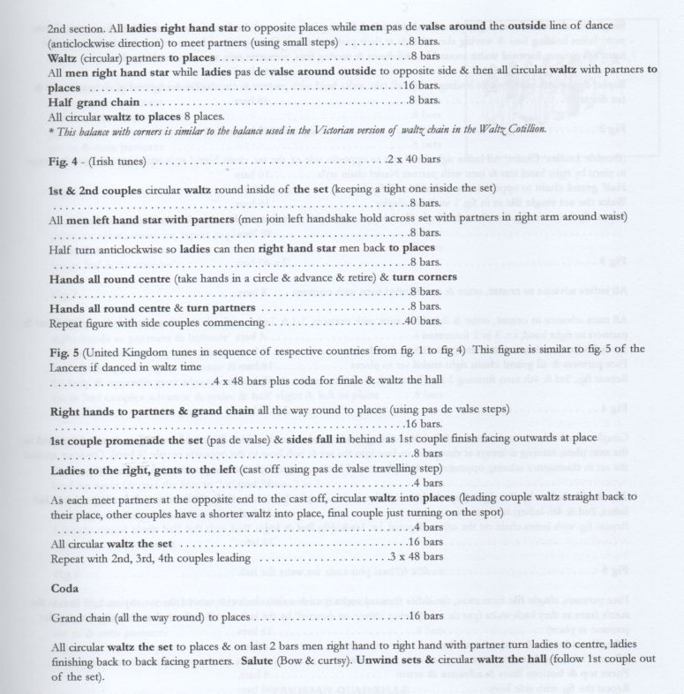 | 12 bars

BARN DANCE (Progressive)
Formation: Circle of couples facing line of dance.
Start: Open ballroom hold

2 Bars Forward,2,3, lift inside foot-- (Walk 3 steps forward,
all start outside foot, 4th beat raise inside foot).
2 Bars Back 2,3, 4(Start on the raised foot, take 3 steps backward,
4th beat feet together)
4 Bars Turn lady on -- (Lady turns under man's right arm 4 steps,
to the man in front of her, man walks 4 steps back
to women behind him).
2 Bars to centre ladies backward men fwd-- (1,2,3 lift).
2 Bars and back- ladies fwd men backwards-- (1,2,3 together).
4 bars Circular waltz -- (Twice, in 4/4 time).
CHICAGO SWING (1939) Aust Couple dance
Music Charleston/Quickstep

Holding inside hands facing LOD
2 Bars Start outside feet 4 steps fwd
2 Bars Tap 2 steps out, in and out and in
2 Bars Starting outside feet step lock & step
2 Bars Starting inside feet step lock step
2 Bars Starting outside feet walk away from partner
4 steps in a circle man anti clockwise
Lady clockwise
2 Bars Man steps towards partner left foot & taps
Lady steps backwards right foot and taps
Repeat in opposite direction
2 Bars 2 chasse steps down LOD
2 Bars Facing LOD Step away from each other
Then together

MARGARET'S WALTZ 32 bar Waltz
Scicilian Circle
4 Bars Advance and retire
4 Bars Right hand turn opposite
4 Bars Left hand turn partner
4 Bars Half ladies chain
4 Bars 2 Chasse to right 2 chasse to left
(end back to back with other cpl)
4 bars Right hand star
4 bars Right Do si do opposite
4 bar Waltz on past opposite couple

PETRONELLA Scottish 32X8 Reel
Longwise
2 Cpl dance 4 Cpl set

4 Bars 1st Lady two Pas de Basque full turn to centre of set to
her diagonal right 1st man does the same they end
up facing each other and set.
12 Bars Repeated 3 more times to finish in place
8 Bars 1st Couple lead down the centre and back
8 Bars 1st & 2nd Couple Pousette

Repeat from 2nd place and 3rd place finish at bottom of set
Each couple repeats
Traditionally the couple dancing with the active couple can
join the Petronella

Lancers

Figure 1 – 4 x 32 bars
Honour partners and corners (intro) | 8 bars
1st lady & opposite gent swing in the centre, partners crossover | 16 bars
With partners lead through (active between opposite) to places & swing corners | 16 bars
repeat 2nd, 3rd & 4th ladies.

Figure 2 – 4 x 32 bars
1st couple lead up & back, advance to centre & swing | 16 bars
form top & bottom lines advance & retire twice | 8 bars
swing partners | 8 bars
repeat 2nd, 3rd, 4th couples (with 3rd & 4th side lines)

Figure 3 – 2 x 32 bars
All ladies to the centre and back and advance again gents follow to form basket  Basket left | 8 bars  8 bars
Gents' left hand across, form a mill ladies on man’s right and promenade  (woman’s left arm on man’s shoulder, Man’s around Ladies waist)  Repeat once | 16 bars

Figure 4 – 4 x 48 bars
1st & 2nd couples visit right & left | 8 bars
hands across & back again (right & left star) | 8 bars
both hands across and circle left & right (baskets) | 16 bars
4 hands round, circle left & right | 16 bars
Repeat with 3rd & 4th couples visiting right & left
the figure is then repeated 2 more times, but left & right.

Figure 5 – 4 x 48 bars plus coda
Right hands to partners, (full) grand chain (& short swing) | 16 bars
1st couple lead up & back to place facing out | 8 bars
side couples ‘fall in ' 3rd, 4th' cast ladies to the right, gents to the left (cast off) | 8 bars
side lines advance & retire twice | 8 bars
swing partners to place | 8 bars
Repeat grand chain, 2nd, 3rd, 4th couples lead up & back, (top & bottom lines for 2nd cpl) 3rd & 4th cpls side lines, Couples fall in line 2nd couple to right of active couple 3rd in line cpl to left of active.  Coda Grand Chain all the way to place and swing  PRIDE OF ERIN Written by C Wood of Leith, 1911  Scotland to celebrate the Irish in Scotland  Partners in Open Ballroom hold facing line of dance (LOD) / 32 bars  4 Starting on outside feet, take 2 slow steps forward, then 3 steps forward raising inside feet to about ankle height, toe pointed. (SSQQS)  4 Starting with inside foot take 2 slow steps backward. Then 3 steps backward (SSQQS) turning to face partner and join hands.  2 Man swivels right foot, lady swivels left then step other foot against LOD. Then men swivels left steps forward right, lady swivels right steps forward left then repeat.  2 Repeat swivels and steps.  4 Turn to face LOD and waltz solo along LOD 2 turns (12 steps), finish facing partner.  4 Holding hands balance forward (on left) and back then waltz to opposite places, lady passing under man’s right arm.  4 Repeat back to place.  8 Waltz  RUSSIAN TANGO Aust  16 Bar  Line of three facing LOD  4 Bars Line walk 8 steps fwd  4 bars Line walk 8 steps backward  4 bars Middle person raises right arm and left person under arm  And back to place  Middle person raises left arm and right hand person  under arch and back to place  4 bars Middle person kisses left partner then right partner  Then ladies move on to next middle person  Waltz Cotillion 4 x128 bars waltz  Quadrille set – numbering 1st couple back to band, 2nd opposite, 3rd to 1sts right and 4th to 1^{sts} left  PALAIS GLIDE Line of people  Music in 8 Bar phrases  4/4 music  Start with left foot  Point left heel diagonally fwd  Step back left foot behing right  Short step to side with right foot  Step fwd and across with left foot in front of right  Point Right heel diagonally fwd  Step back with right foot behind left  Short step to side with left foot  Step fwd and across with right foot in front of left  Point left heel diag fwd then pause  Swing left foot fwd and cross it over in front of right  Swing right foot fwd and cross over in front of left  Swing left foot fwd and cross over in front of right  Swing right foot fwd and cross over in front of left  Step fwd with left foot  Starting right foot 4 quick steps fwd  BOSTON TWO STEP Couple facing LOD  Open extended hold  16 Bar ad lib  6/8 music  4 Bars Pas de Basque outwards & inwards  4 step down LOD  4 Bars Repeat back to place face partner take two hands  4 Bars Pas de Basque down LOD and back  Then side together & side together down LOD  4 Bars Waltz  LUCIAN'S WALTZ 32 bar waltz  Start Couples in circle facing forward around line of dance.  4 Couples face forward around line of dance. Take inside hands and starting on outside foot, take four waltz steps forward.  4 Face partner, and with two-hand open hold take two steps along line of dance and two side steps back.  4 Turn partner slowly around once with four forward waltz steps.  2 Slow balance. Step onto right foot, swing left foot though (while rising on right foot) and back, stepping onto left foot, and then the right foot.  2 Balance similarly to the left. Step onto left foot, swing right foot thought (while rising on left foot) and back, stepping onto the right foot, and then the left foot.  2 Balance once more to the right  2 Both cast out anticlockwise leading with the left shoulder and progress onto the next partner. Ladies progress forward along the line of dance, gents backwards.  4 Take two-handed open hold with new partner and turn slowly around once with four forward waltz steps.  4 Facing forward in line of dance holding inside hands, waltz balance away from partner, and towards partner. Repeat.  4 Take ballroom hold and waltz.  Arkansas Traveller 32X4 American Reel  quadrille (square) formation,  numbering tops and sides. Walked | 16 bars+
  Couples 1 waltz inside the set to place | 16 bars
  Ladies 1&2 balance forward and back and cross by right | 8 bars
  Ladies 3&4 repeat | 8 bars
  Men 1&2 repeat | 8 bars
  Men 3&4 repeat | 8 bars
  Couples 1&2 waltz partners to place | 8 bars
  Couples 3&4 waltz partners back to place | 8 bars
  (Sides divide to form top and bottom lines)  Lines advance and retire and pass through  (2 steps to advance 2 steps to retire & 4 to cross over) | 8 bars
  Lines repeat to place | 8 bars
  All balance waltz chain to place | 32 bars
  All waltz partners to place | 16 bars
  Repeat with each couple waltzing the set to start 3 x 128 bars
  When sides leading ladies 3&4 lead the cross over
  And tops dividing to form side lines
  8 Bars Tops advance and retire twice
  4 Bars Tops turn opposite by right (arm). Then partner by left
  2 Bars All turn corners by right
  2 Bars All turn partners by left
  8 Bars All Swing corners – ballroom hold
  8 Bars All Promenade corners to man’s place
  Repeat with tops couples leading again | 32 bars
  Repeat twice with sides leading  SWING WALTZ Music: 32 bar waltz  Formation: Couples, start inside hand hold & start outside foot, both facing anticlockwise LOD  4B Advance 3 steps & raise inside foot. Retire 3 steps (start inside  feet finish with feet together)  2B Waltz solo turn – finish 2-hand hold with Partner  2B Chassé 2 steps sideways along LOD (step close, step close).  2B Chassé 2 steps back against line of dance – finish facing  LOD holding nearer hands  2B Step apart 1 waltz step (keeping hands joined) + Change  places (Lady turns under Gent's right arm) – finish facing against LOD  2B Repeat step away & change places – finish facing along LOD  2B Step away starting inside feet 3 steps to Finish facing Partner  & take 2-hand hold  2B Step & balance forward + Step & balance against line of dance  2B Starting men’s left ladies right Turn to be back to back 3 steps  & balance forward in LOD, keeping nearer hands joined.  2B Balance against line of dance then forwards turning take  3 steps to face Partner & taking 2-hand hold.  2B Step balance through + Step balance back  2B Lady turn under Gent's left arm progressing along line of dance,  while man dances 3 steps forward  2B Lady turn back (under Gent's left arm) dancing back against line  of dance while man dances 3 steps backwards  4B Waltz on (should be reverse waltz)  WHITE DOG RAG Aust 32 Bar Ragtime  3 facing 3 around the hall  8 Bars All advance and retire  Centre person ½ Reel of 3 with 2 people on right  (Passing diagonal opp person by left to begin)  8 Bars repeat  8 Bars Centre people R & L hand turns  While face partners in line and full R & L’s  8 Bars All advance & retire  Advance and step to right & honour  and pass thru by left shoulder and meet new line  repeat  EVENING THREE STEP  Couples facing LOD holding inside hands/16bar 4/4 or 6/8 music  2B Both starting outside feet take 3 steps fwd, bring feet together  2B Start inside feet change places with partner, lady in front, turning towards partner pivot turn. Bring feet together  2B Repeat back to place  2B Starting inside feet 3 steps backwards against LOD bring feet together  4B Travelling down LOD facing partner one skip-23, Swivel back to back one skip-23, swivel to face partner chasse 2 steps  4B Waltz (Rotary Chasse)  Circle Waltz Australian Circle dance 32 bar waltz I  16 Bars Take hands in a circle, all balance into the centre  and then out to place (gents start left foot ladies right foot)  Gents then guide their left hand lady across in front of him  to his right hand side. The lady may move across or turn  under his arm as in waltz country dance.  This movement is done four times.  8 Bars Facing your new partner, take an open hand hold.  Sway into the circle and out, and then drop hands and both  do a single waltz turn towards centre.  Repeat swaying out and then in and a turn back to place.  Finish in ballroom hold.  4 Bars Couples take two chasse steps into the centre of the circle,  and then two chasse steps out to place.  4 Bars Waltz around the circle, finishing in an open circle. | 64 bars

